The ninth MCI Project client meeting will be held in Ingkarni Wardliat 3.30 pm on Tuesday 25th May 2021.

**Agenda**

**Chair:** Yupeng Hou

**Secretary:** Ying Li

# Main Goal for the meeting

# Present the project progress that we have made in the previous week.

# Ask clients for their preferences and requirements about the function of showing the fields and hiding entries.

# Functional requirements and Presentations in Last Meeting

* Presented the deployed version of the project to clients.
* Clients tested the deployed project and provided some feedback.
* Improve the efficiency of filter function.
* Implement the function of displaying each fields of an entry.
* Implement the function of hiding entries.
* Implement the function of distinguishing researchers having the same name.

# Summary of the project progress

3.1 Project progress:

* The efficiency of filter has been improved. The original button named ‘deselect all’ has been divided into ‘select all’ and ‘deselect all’ (Figure 1).

Figure 1. Filter function

* Implemented the function of showing fields of the entries (Figure 2), which could help users easily know the existing fields and edit the BibTex fields.

Figure 2. Showing fields of entry

* Implemented the hidden function (Figure 3). In the Customise BibTex fields function, enter ‘HIDE’ in ‘Field name’ and any value in ‘Field value’, and then this entry will be hide. The hide history has been recorded in parse_log (Figure 4). If users want to show the hidden entry, users need to find the corresponding BibTex url in parse_log, and then enter ‘HIDE’ in ‘Field name’ and ‘DELETE’ in ‘Field value’. The corresponding entry will show up.



Figure 4. The hidden entry

* The AGUP management system can distinguish researchers having the same name (Figure 5).

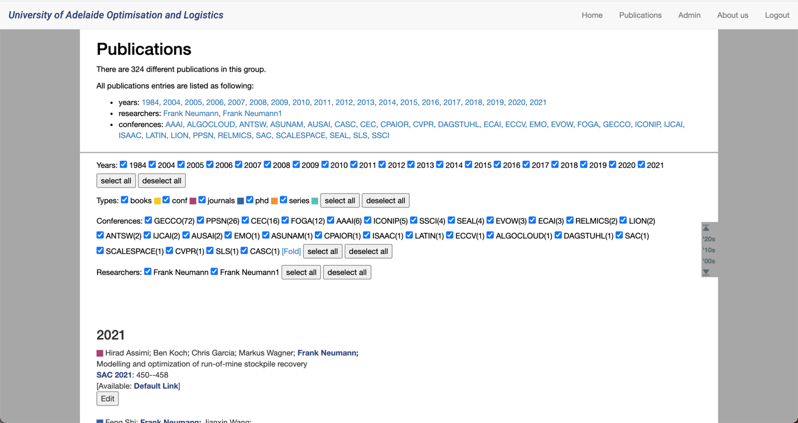

Figure 5. Researchers with the same name

3.2 Other progress:

* Finished testing plan.

# Requirements Elicitation

Receive the feedback about the current implementation from clients.

Note: Next client meeting will be held on 1st June 2021